import java.util.Scanner;

public class NamePrinter {
// Field (attribute)
String name;

// Method to input the name and print it
public void getNameAndPrint() {
// Create a Scanner object to read input from the user
Scanner scanner = new Scanner(System.in);

// Prompt the user to enter their name
System.out.print("Enter your name: ");
name = scanner.nextLine(); // Read the user input

// Print the name
System.out.println("Hello, " + name + "!");

// Close the scanner
scanner.close();
}
public static void main(String[] args) {
// Create an object of the NamePrinter class
NamePrinter user = new NamePrinter();

// Call the method to input the name and print it
user.getNameAndPrint();
}
}
import java.util.Scanner;

public class NamePrinter {
// Field (attribute)
String name;

// Method to print the name
public void printName() {
System.out.println("Hello, " + name + "!");
}

public static void main(String[] args) {
// Create a Scanner object to read input from the user
Scanner scanner = new Scanner(System.in);

// Prompt the user to enter their name
System.out.print("Enter your name: ");
String userName = scanner.nextLine(); // Read the user input

// Create an object of NamePrinter and pass the user name
NamePrinter user = new NamePrinter();
user.name = userName; // Set the name field from the main method

// Call the method to print the name
user.printName();

// Close the scanner
scanner.close();
}
}
public class Calculator {

// Method with parameters 'a' and 'b'
public int add(int a, int b) { // 'a' and 'b' are parameters
return a + b;
}

public static void main(String[] args) {
Calculator calc = new Calculator();

// Passing 5 and 3 as arguments
int result = calc.add(5, 3); // 5 and 3 are arguments
System.out.println("The result is: " + result);
}
}

public class Calculator {

// Fields (attributes)
int a;
int b;

// Constructor to initialize the values of 'a' and 'b'
public Calculator(int a, int b) {
this.a = a; // Initialize 'a' with the passed argument
this.b = b; // Initialize 'b' with the passed argument
}

// Method to add 'a' and 'b'
public int add() {
return a + b; // Use the values stored in 'a' and 'b'
}

public static void main(String[] args) {
// Create a Calculator object and pass values to the constructor
Calculator calc = new Calculator(5, 3); // 5 and 3 are passed as arguments to the constructor

// Call the add method to get the result
int result = calc.add(); // No arguments needed, uses the values from the constructor

// Print the result
System.out.println("The result is: " + result);
}
}

// this is for accessing data with out arrlength
For accessing array int arr[]=(10,20,30,40,50)
For(data:arr)
Print data

// for break and continue
Break- skip the one parent loop
Continue just- skip the down process
Return- return from where it comes from

// calling function
Class Car {
Static void carName(){
System.out.println(“Ferrari”);
}
Public void maxspeed(){
System.out.println(“360”);
}
}
Public class FirstJava{
Public static void main(Strig)
Car.carname // accessing with out object because this function is static
Car c= new Car(); // two car should be same
c.maxspeed // accessing as object because this function in public
}

// object dynamically allocate memory in run time
i.e Box boxVar; //it is null
boxVar = new Box(); // now it has memory
// private
Inner classes
Public ,private ,protected ,inheritance,extended ,static
Construcor can be different name ??
If we use extend keyword that is only sub class..
In extend we cannot use private of class
Child only access parent but parent cannot access child in heritance.

Abstraction---------------------------------------------------------
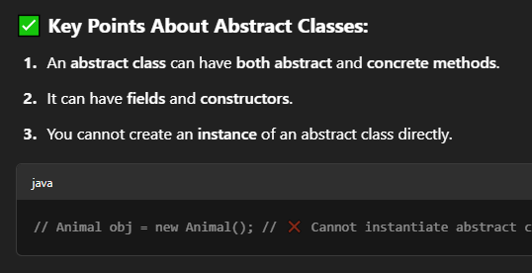
class Animal {
String name = "Animal";
}

class Dog extends Animal {
String name = "Dog";

void display() {
System.out.println(super.name); // prints "Animal"
System.out.println(this.name); // prints "Dog"
}
}

Static---------------------------------------------------------------------------------------
class Counter {
// Static variable
private static int count = 0;

// Static method to increment count
public static void increment() {
count++;
}

// Static method to get the current count
public static int getCount() {
return count;
}
}

public class Main {
public static void main(String[] args) {
// Calling static methods without creating an instance of Counter
Counter.increment(); // count becomes 1
Counter.increment(); // count becomes 2

System.out.println("Count: " + Counter.getCount()); // Outputs: Count: 2
}
}
**** without making an object of class u can call a static

--------------------final word
class Circle {
// Final variable
public static final double PI = 3.14159;

public double calculateArea(double radius) {
return PI * radius * radius; // PI cannot be changed
}
}

public class Main {
public static void main(String[] args) {
Circle circle = new Circle();
System.out.println("Area: " + circle.calculateArea(5)); // Outputs area using final PI
}
}
***** as a constant keyword-------------------------------------------
******The FinalClass cannot be extended because it is declared as final. If we try to create a subclass of FinalClass, it will cause a compile-time error.

Access modifier
-------------------------------------privae -----------------------------------------------
class BankAccount {
private double balance;

public void deposit(double amount) {
if (amount > 0) {
balance += amount; // Accessed within the same class
}
}

public double getBalance() {
return balance; // Accessed via a public method
}
}

public class Main {
public static void main(String[] args) {
BankAccount account = new BankAccount();
// account.balance = 1000; // Error: balance is private
account.deposit(500); // Access allowed through public method
System.out.println("Balance: " + account.getBalance()); // Access allowed through public method
}
}
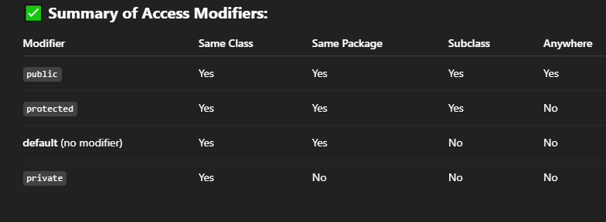
✅ Quick Check (Mini Quiz)
- What is the result of 10 % 3?
- What does == do in Java?
- How do you write a condition that checks if a number is not equal to 100?
- Write a ternary operator to check if a person is eligible to vote (age ≥ 18).
- Will this print true?
java
CopyEdit
String name = "Java";
System.out.println(name instanceof Object);

Java topics
1. Introduction to Java
- History and Features of Java
- Java Editions (SE, EE, ME)
- JVM, JRE, and JDK
- Java Program Structure
- Compilation and Execution

2. Data Types and Variables
- Primitive Data Types
- Reference Data Types
- Type Conversion and Casting
- Constants and Literals
- Variable Scope and Lifetime
- Data Type | - Size | - Example
- byte | - 1 byte | - byte b = 100;
- short | - 2 bytes | - short s = 1000;
- int | - 4 bytes | - int a = 5000;
- long | - 8 bytes | - long l = 123456789L;
- float | - 4 bytes | - float f = 3.14f;
- double | - 8 bytes | - double d = 99.99;
- char | - 2 bytes | - char c = 'A';
- boolean | - 1 bit | - boolean flag = true;

3. Operators and Expressions
- Arithmetic Operators
- Relational Operators
- Logical Operators
- Bitwise Operators
- Assignment and Unary Operators
- Ternary Operator
- Operator Precedence

4. Control Flow Statements
- Decision Making: if, if-else, switch
- Loops: for, while, do-while
- Jump Statements: break, continue, return

5. Object-Oriented Programming (OOP)
- Class and Object
- Constructors
- this Keyword
- Inheritance
- Method Overloading and Overriding
- super Keyword
- Polymorphism
- Abstraction (abstract, interfaces)
- Encapsulation
- Static Members
- Final Keyword

6. Arrays and Strings
- One-Dimensional and Multi-Dimensional Arrays
- Array Operations
- String Class and Methods
- StringBuilder and StringBuffer

7. Packages and Access Modifiers
- Built-in Packages (java.util, java.io, etc.)
- User-defined Packages
- import Statement
- Access Modifiers: public, private, protected, default

8. Exception Handling
- Types of Exceptions
- try, catch, finally
- throw and throws
- Custom Exceptions

9. Java Collections Framework (JCF)
- List (ArrayList, LinkedList)
- Set (HashSet, LinkedHashSet, TreeSet)
- Map (HashMap, TreeMap, LinkedHashMap)
- Queue and Stack
- Iterators and Enhanced for-loop

10. File Handling
- File Class
- Reading and Writing Files
- FileReader, FileWriter
- BufferedReader, BufferedWriter
- Serialization and Deserialization

11. Multithreading and Concurrency
- Thread Class and Runnable Interface
- Thread Lifecycle
- Synchronization
- Inter-thread Communication
- Executor Framework

12. GUI Programming (AWT and Swing)
- AWT Components
- Swing Components (JFrame, JPanel, JButton, etc.)
- Event Handling
- Layout Managers

13. JavaFX (Modern GUI Toolkit)
- Application Lifecycle
- Scene Graph and UI Controls
- FXML and CSS
- Event Handling in JavaFX

14. Networking in Java
- InetAddress, Socket, ServerSocket
- URL and HttpURLConnection
- Client-Server Communication

15. JDBC (Java Database Connectivity)
- Connecting to a Database
- Statements and ResultSet
- PreparedStatement
- CRUD Operations
- Connection Pooling

16. Annotations and Reflection
- Built-in Annotations (@Override, @Deprecated, etc.)
- Custom Annotations
- Reflection API

17. Lambda Expressions and Streams (Java 8+)
- Functional Interfaces
- Lambda Expressions
- Stream API (map, filter, reduce)
- Method References

18. Modules (Java 9+)
- Introduction to Modules
- module-info.java
- Module Dependency

19. Java Development Tools
- IDEs: IntelliJ IDEA, Eclipse, NetBeans
- Build Tools: Maven, Gradle
- Debugging and Testing (JUnit)

20. Best Practices and Design Patterns
- SOLID Principles
- Common Design Patterns (Singleton, Factory, Observer, etc.)
- Clean Code and Documentation

import java.io.*;
import java.util.Scanner;

public class BufferedExample {
public static void main(String[] args) {
Scanner scanner = new Scanner(System.in);
String filePath = "buffer_example.txt";

try {
// Step 1: Take input from console
System.out.print("Enter a message: ");
String message = scanner.nextLine();

// Step 2: Write using BufferedWriter
BufferedWriter writer = new BufferedWriter(new FileWriter(filePath));
writer.write(message);
writer.newLine(); // optional: adds a new line
writer.close();
System.out.println("Message written to file.");

// Step 3: Read using BufferedReader
BufferedReader reader = new BufferedReader(new FileReader(filePath));
String line;
System.out.println("Reading from file:");
while ((line = reader.readLine()) != null) {
System.out.println(line);
}
reader.close();

} catch (IOException e) {
System.out.println("Error: " + e.getMessage());
}

scanner.close();
}
}

